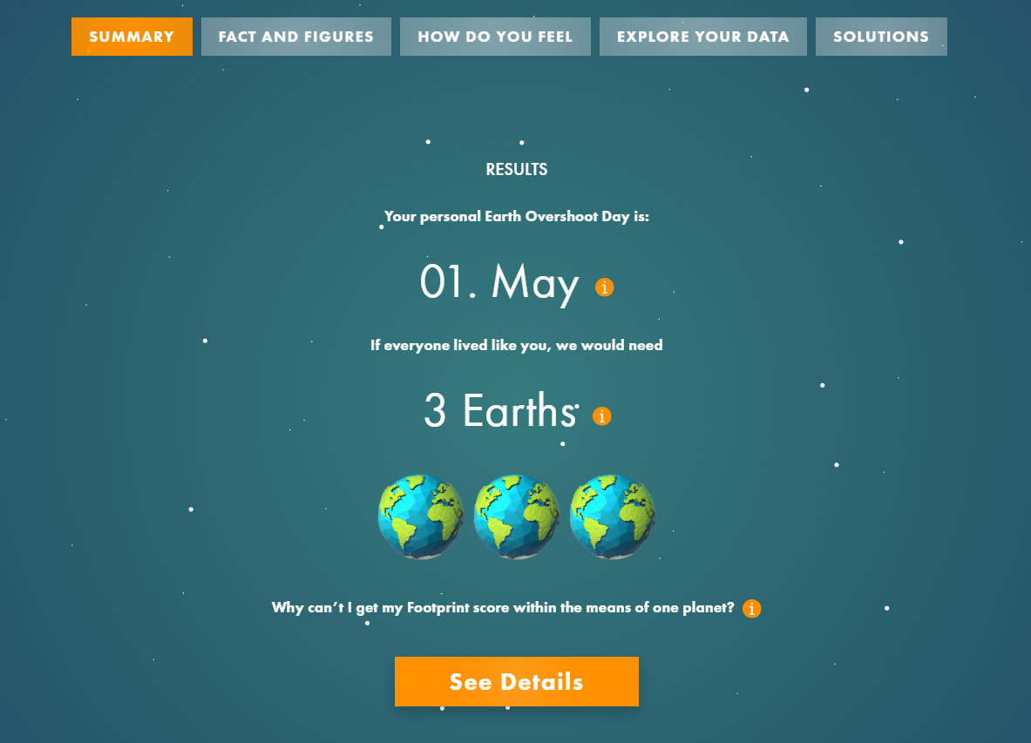

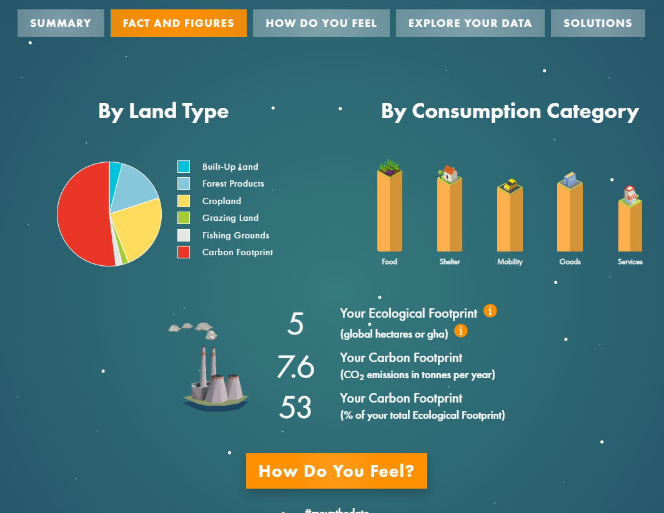

Important terms to know:-

Ecological Footprint: The **ecological footprint** measures the human demand on [natural capital](https://en.wikipedia.org/wiki/Natural_capital), i.e. the quantity of nature it takes to support people or an economy. The accounts contrast the biologically productive area people use for their consumption to the biologically productive area available within a region or the world. In short, it is a measure of [human impact on the environment](https://en.wikipedia.org/wiki/Human_impact_on_the_environment).

Biocapacity: [Biocapacity](https://www.buschsystems.com/resource-center/knowledgeBase/glossary/what-is-biocapacity) – or biological capacity – is the ability ecosystems can provide natural resources and absorb the [Waste](https://www.buschsystems.com/resource-center/knowledgeBase/glossary/what-is-waste) produced by humans. The biocapacity of the Earth is a problem that continues to grow as humanity progresses.

Overshoot day: Earth Overshoot Day (EOD) refers to a calculated illustrative date of a year when human consumption of the resources exceeds the capacity. The word ‘overshoot’ signifies the surpassing figure by which the demand of the human beings exceeds the resources regenerated.

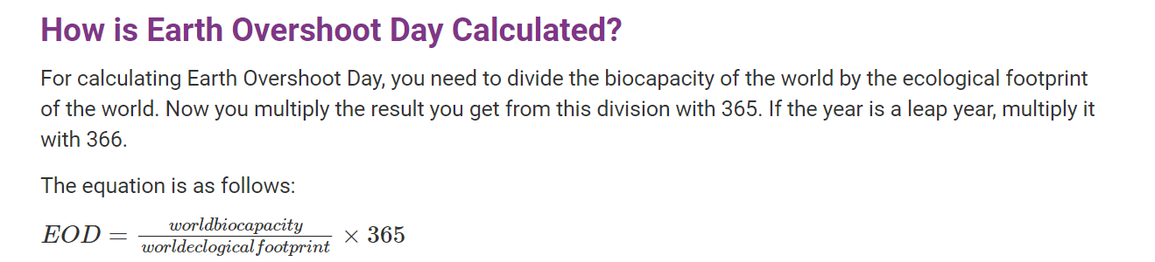

Footer to my report:

When the body is heavy, the footprint deeply hurts the earth. A lighter footprint is a valuable quality in a world with limited productive land and growing population. In our planet it is increasingly necessary to conserve energy and materials, reduce emissions of greenhouse gases and at the same time, to live in peace, with well-being and in a non-violent way.

India’s [Ecological Footprint](http://www.footprintnetwork.org/our-work/ecological-footprint/)—the amount of productive land and sea area required to produce the resources it consumes and absorb its waste—has doubled since 1961, according to the report. Today, the country’s total demand on biocapacity is exceeded only by the United States and China.

India now demands the biocapacity of two Indias to provide for its consumption and absorb its wastes, according to a report released by Global Footprint Network and [CII (Confederation of Indian Industry)](http://www.cii.in/).

Currently, humans are consuming 1.7 times the resources the Earth can replace in one year. By 2030, humans will require the resources produced on two Earths. In the Indian context, the country will require 2.5 times more natural resources to meet its demand by 2030.

India has lower per-capita consumption of natural resources than many countries, but overshoot occurs due to its high population and limited resources. India has about 18 per cent of the world’s population, while its land, forest and clean water make up a meagre 2.4, 2 and 4 per cent of the world’s respective totals.

Represented as land area, the natural resources available to sustain people in India take up 0.5 hectares per person, while consumption is around 1.1 hectares per person.

Earth’s overshoot day in 2022 is July 28. Overconsumption of the Earth’s resources means anything consumed after July 28 is debt borrowed from the Earth’s future. If it is not slowly repaid, exhaustion of the existing resources on Earth will put human existence in danger.

According to the Global Footprint Network report, overfishing, indiscriminate deforestation and excessive carbon-dioxide emissions are the main reasons for the Earth’s overshoot. The Earth cleans the atmosphere by absorbing carbon dioxide. The report finds the natural resources needed to scrub carbon dioxide from the atmosphere make up about 60 per cent of the total ecological footprint.

About 78.5 per cent of electricity in India comes from fossil fuels, followed by renewable sources (19 per cent) and nuclear sources (2.5 per cent). Coal has the largest share (44 per cent) of India’s electricity supply.

Human activities utilize resources and [produces waste](https://www.conserve-energy-future.com/15-easy-ways-to-reduce-landfill-waste.php). As the [human population increases](https://www.conserve-energy-future.com/causes-effects-solutions-of-overpopulation.php), the global consumption and utilization of resources increases. This calls for the measure of the nature’s capacity to meet the increasing demand by people.

The vehicles, ships, airplaces, machines using fuel, gas, oil emit a lot of carbon behind which is a threat to the environment. This means that the more the miles to transport the more carbon emissions and [greenhouse gasses](https://www.conserve-energy-future.com/greenhouse-gases.php) are released into the atmosphere.

According to the National Footprints Accounts (2014), India has an ecological footprint of 1.12 global hectares (gha) per person and a biocapacity of 0.45 gha per person which means it is a ‘biocapacity debtor’ or an ‘ecologically deficit country’ with there being a 148 per cent more demand than supply on its natural resources.

If a population’s Ecological Footprint exceeds the region’s biocapacity, that region runs a **biocapacity deficit**. Its demand for the goods and services that its land and seas can provide—fruits and vegetables, meat, fish, wood, cotton for clothing, and carbon dioxide absorption—exceeds what the region’s ecosystems can regenerate. In more popular communications, we also call this “an ecological deficit.” A region in ecological deficit meets demand by importing, liquidating its own ecological assets (such as overfishing), and/or emitting carbon dioxide into the atmosphere. If a region’s biocapacity exceeds its Ecological Footprint, it has a **biocapacity reserve**.